
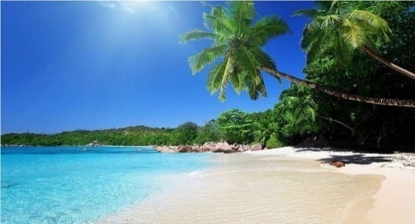



Bhitarkanika National park
Day Wise Itinerary:
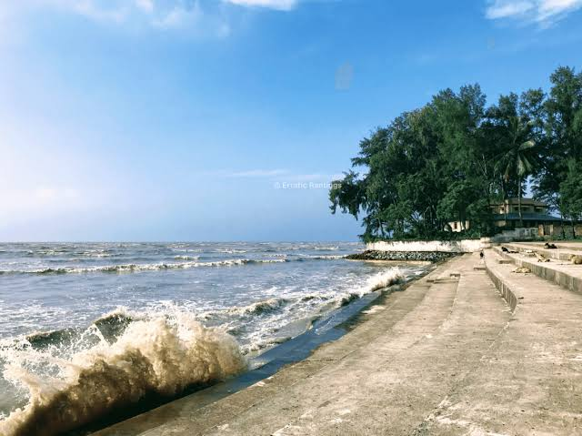
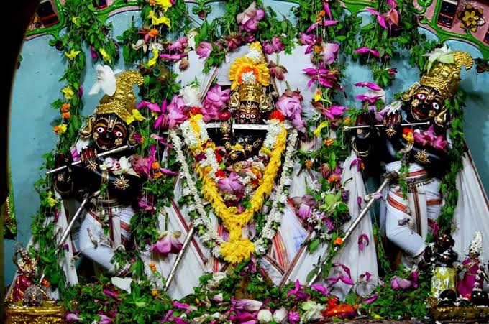
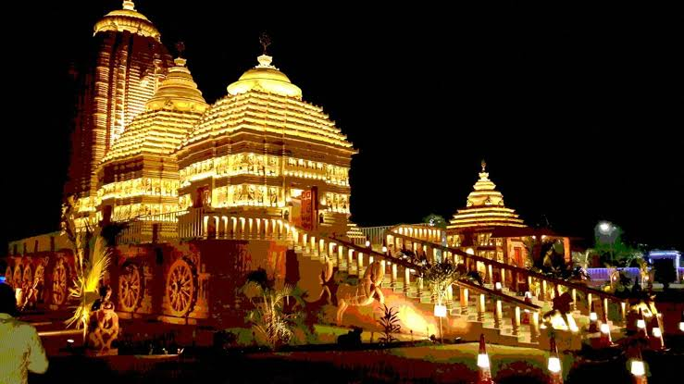
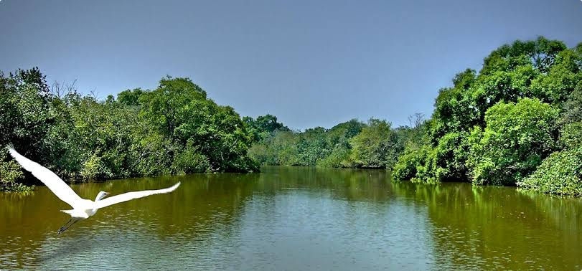
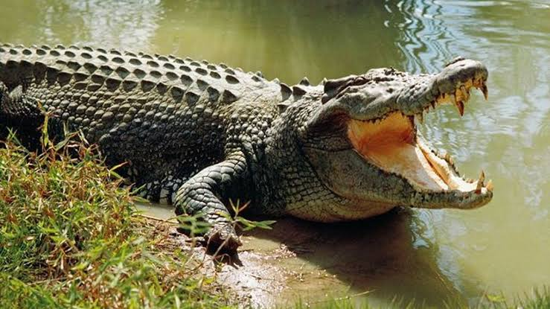
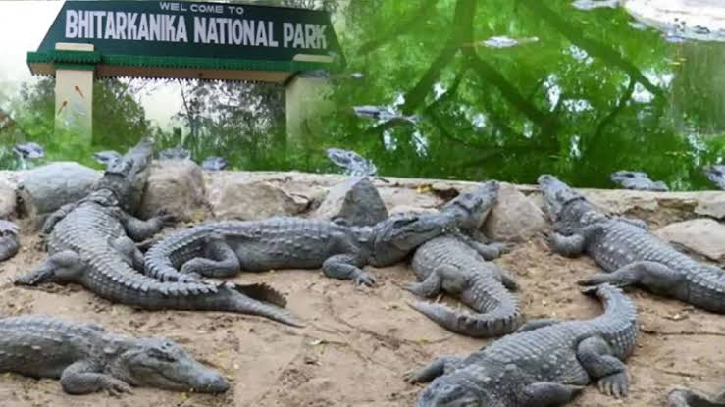

(1st Day) Sightseeing – Tatanagar to

- Pickup from station to hotel after launch local sightseeing khumkut Dam, biseswar pahad stone carving

(2nd Day) Sightseeing

- Bhitarkonica crocodile project dangmol forest zoo crocodile park etc.

(3rd Day) Sightseeing

- Panchalingeswar temple then chandipur sea beach, buribalm river, Radhakrishna temple, emami jagannath temple, khirchora gopinath nilgiri then return to hotel

(4th Day)

- Return to Tatanagar

Package Inclusion:
- Meals as per itinerary (B+L+D)
- Comfortable Hotel
- Comfortable vehicle
- Train Ticket
- Package cost *5,900* /Rs. Triple Sharing
- Package cost *6,900* /Rs. Double Sharing

Package Excluded:

- Personal Expenses

Cancellation Policy :
- Minimum Cancellation is Rs. 1000/- per Head.
- 25% Between 30-20 Days Before Tour Departure
- 50% Between 20-10 Days Before Tour Departure
- 75% Between 10-05 Days Before Tour Departure
- 100% on the Same Day & No show.

